INTRODUCTION TO PYTHON
WHAT IS PYTHON?
Python is a high-level, general purpose programming language. It’s design philosophy emphasizes code readability with the use of significant indentation. It was created by GUIDO VAN ROSSUM, and released in 1991.
It is used for:
- Web development
- Software development
- Mathematics
- System scripting
WHAT CAN PYTHON DO?
- Python can be used on a server to create web applications
- Python can be used alongside software to create workflows
- Python can connect to database systems. It can also read and modify files.
- Python can be used to handle big data and perform complex mathematics.
- Python can be used for rapid prototyping, or for production-ready software development.

How to install Python
Most computers already have python installed, though it’s likely an old version.
To check if you have python installed on a Windows PC, search in the start bar for Python or run the following on the Command Line (cmd.exe):
C:\Users\Yourpc Name>python --version
To check if you have python installed on a Linux or Mac, then on linux open the command line or on Mac open the Terminal and type:
python --version
If you find that you do not have python installed on your computer, then you can download it for free from the following website: https://www.python.org/
For this tutorial we are going to be using Visual studio code so go ahead and download it from https://www.visualstudiocode.com/ , the installation is quite straightforward.
After installing Visual studio code, open it and click the extensions icon by the left:
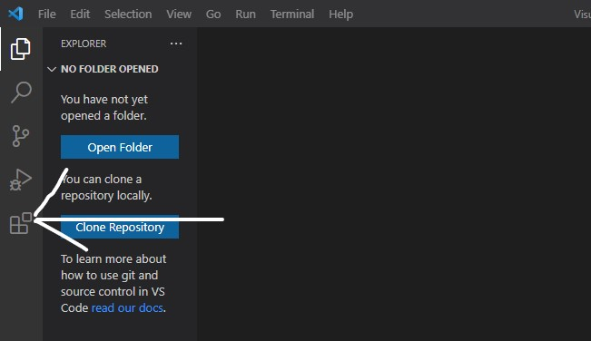

Search for “python” in the extension tab and install the one made by Microsoft.

The Python Command Line
To quickly test a code it is easier to use the python command line, instead of creating a python file.
Type the following in your terminal to open the python command line/shell:
C:\Users\user>python
From here you can write code python:
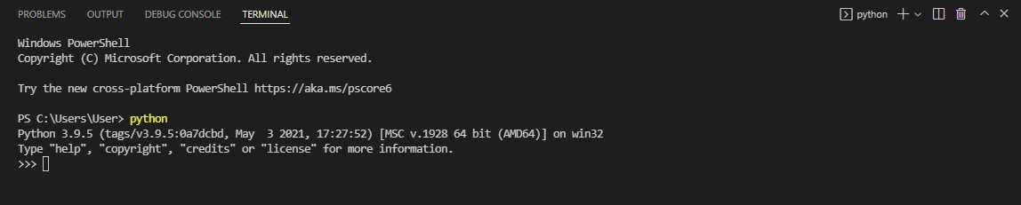
Let us print "Hello, World!" in the command line:
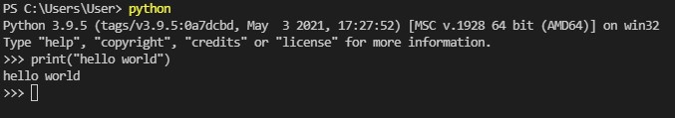
When you are done, to close the python command line type:
exit()

Typing things in

Case matters a lot in python. In Python, print, Print, and PRINT are all different things. For now, we’ll stick with lowercase as most Python statements are in lowercase.
Spaces matter at the beginning of lines, but not elsewhere. For example, the code below will not work.
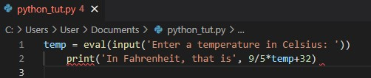

Python uses indentation of lines for blocks of code or we can say sections or functions; we will learn this well further in this tutorial. On the other hand, spaces in most other places don’t matter. For instance, the following lines have the same effect:
print('Hello world!')
print ('Hello world!')
print( 'Hello world!' )
Indentation refers to the spaces at the beginning of a code line. In other programming languages the indentation in code is for readability only, the indentation in Python is very important.

Example
if 5 > 2:
print("Five is greater than two!")
Python will give you an error if you skip the indentation:

Example
Syntax Error:
if 5 > 2:
print("Five is greater than two!")
You have to use the same number of spaces in the same block of code, otherwise Python will give you an error:

Example
Syntax Error:
if 5 > 2:
print("Five is greater than two!")
print("Five is greater than two!")

Variables
When programming, you store information in variables. A variable is a kind of storage box. Whenever you want to work with the information, you access it using the variable. If you have new information you want to store, you put it in a variable. Changing information means accessing the variable first and then storing the new value in the variable. Just as you store things in boxes in the real world, so you store things in variables (a kind of storage box) when working with applications.
EXAMPLE:
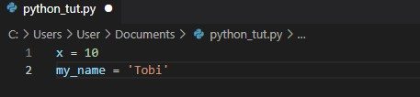

To place a value into any variable, you make an assignment using the assignment operator (=); we will talk about operators later on.
A variable is created the moment you first assign a value to it.

Example
x = 5
y = "John"
print(x)
print(y)
Variables do not need to be declared with any particular type and can even change type after they have been set.

Example
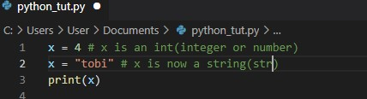
String variables can be declared either by using single or double quotes:

Example
x = "John"
# is the same as
x = 'John'

Variable Names
A variable can have a short name (like x and y) or a more descriptive name (age, carname, total_volume). Rules for Python variables:
- A variable name must start with a letter or the underscore character
- A variable name cannot start with a number
- A variable name can only contain alpha-numeric characters and underscores (A-z, 0-9, and _ )
- Variable names are case-sensitive (age, Age and AGE are three different variables)
IMPORTANT NOTE: variable names are case-sensitive.

How to assign Value to Multiple Variables
Python allows you to assign values to multiple variables in one line using the “=” symbol:

Example
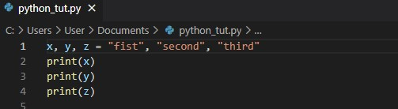
OUTPUT:
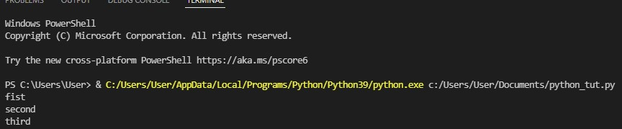

Output Variables
The Python print function is used to output the value of variables to the terminal.
Here is a simple example:
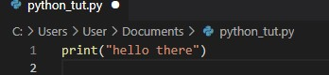
The print function requires parenthesis ”()” around its arguments. In the program above, its only argument is the string 'Hello there. Anything inside quotes will(with afew exceptions) be printed exactly as it appears. In the following, the first statement will output 3+4, while the second will output 7.
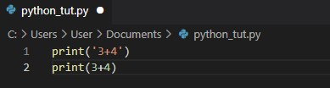
To print several things at once, separate them by commas. Python will automatically insert spaces between them. Below is an example and the output it produces.
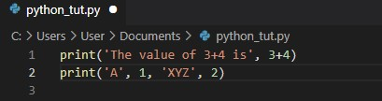
Output:
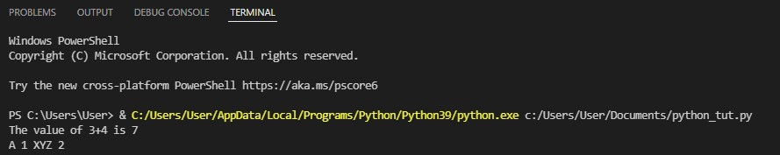
You can also use the + character to add a variable to another variable:

Example
x = "Python is "
y = "awesome"
z = x + y
print(z)
For numbers, the + character works as a mathematical operator:

Example
x = 5
y = 10
print(x + y)
If you try to combine a string and a number, Python will give you an error.

There are two optional arguments to the print function ; “sep” and “end”. They are not overly important at this point, but they are useful for making your output look nice.
“sep” will insert a space between each of the arguments of the print function. There is an optional argument called sep, short for separator, that you can use to change that space to something else. For example, using sep=':' would separate the arguments by a colon and sep='##' would separate the arguments by two pound signs. One particularly useful possibility is to have nothing inside the quotes, as in sep=''. This says to put no separation between the arguments. Here is an example where sep is used:
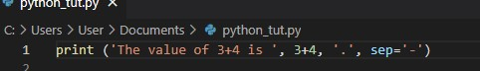
Output:
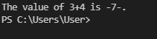

“end” is an optional argument called so that you can use to keep the print function from advancing to the next line. Here is an example:
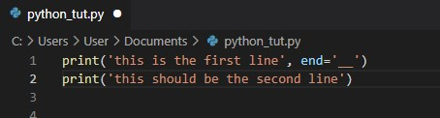

Output:
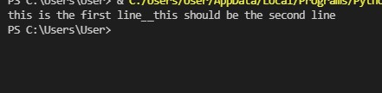

Global Variables
Variables that are created outside of a function are known as global variables.
You have to be careful using global variables, especially in larger programs, but a few global variables used judiciously are fine in smaller programs.
Global variables can be used by everyone, both inside of functions and outside.

Example
Creating a variable outside of a function, and using it inside the function
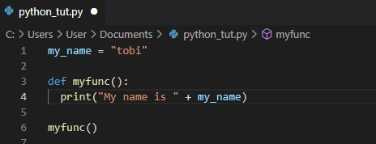

Local variables
When a variable is defined inside a function, it is local to that function, which means it essentially does not exist outside that function. This way each function can define its own variables and not have to worry about if those variable names are used in other functions.
If you create a variable with the same name inside a function, this variable will be local, and can only be used inside the function. The global variable with the same name will remain as it was, global and with the original value.

Example
Create a variable inside a function, with the same name as the global variable
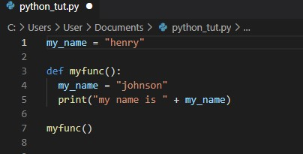
Output:
